Chapter 17, Solution 27.

For the waveform shown in Fig. 17.65 below,

- specify the type of symmetry it has,
- calculate a₃ and b₃,
- find the rms value using the first five nonzero harmonics.

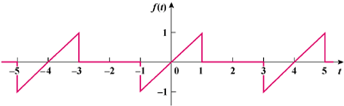

Figure 17.65
For Prob. 17.27.

Solution

(a) odd symmetry.

(b) a_{o} = 0 = a_{n}, T = 4, ω_{o} = 2π/T = π/2

f(t) = t, 0 < t < 1

= 0, 1 < t < 2

b_{n} =

=

= 4(−1)^{(n−1)/2}/(n²π²), n = odd

−2(−1)^{n/2}/(nπ), n = even

a₃ = 0, b₃ = 4(−1)/(9π²) = –0.04503

(c) b₁ = 4/π², b₂ = 1/π, b₃ = −4/(9π²), b₄ = −1/(2π), b₅ = 4/(25π²)

F_{rms} =

F_{rms}² = 0.5Σb_{n}² = [1/(2π²)][(16/π²) + 1 + (16/(81π²)) + (1/4) + (16/(625π²))]

= (1/19.729)(2.6211 + 0.27 + 0.00259)

F_{rms} = = 0.383

Compare this with the exact value of F_{rms} = = 0.4082 or (0.383/0.4082)x100 = 93.83%, close.

